PBIO8250 Final Project

Argrett

5/8/2022

**Study design figure and study questions/hypotheses:**

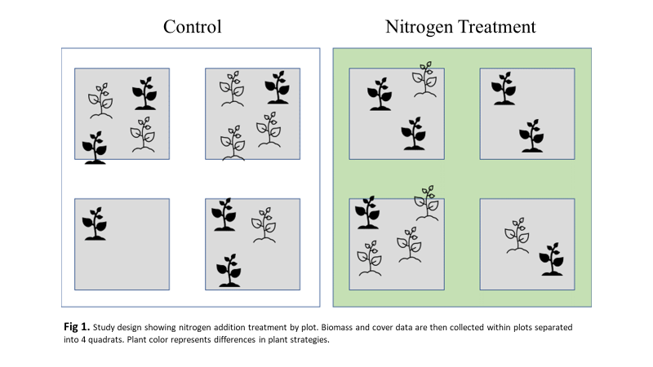

* **What is the effect of Nitrogen addition on biomass production?**
  + We hypothesize a difference in total biomass by treatment over time.
* **What is the effect of nitrogen addition on the biomass production between C3 and C4 photosynthetic species?**
  + We hypothesize a different effect of nitrogen addition on two photosynthetic pathways' total above-ground biomass over time.
* **What is the effect of nitrogen addition on biomass production between annual and perennial plants?**
  + We hypothesize a difference in the total biomass due to the effect of nitrogen addition on life history strategy over time.

**Methods:**

In our analysis, we ran three separate models to test our hypothesis. We compared the total biomass production between fertilizer treatment by year using a linear mixed-effects model and an analysis of deviance walds type II chi-squared (ANOVA) to test our first question. Treatment and Study year were treated as fixed effects, and plot was treated as a random effect (function lme() in the nlme package, Pinhiero et al. 2022). We compared total biomass production between fertilizer treatments, study year, and photosynthetic pathway in our second question using a second linear mixed-effect model and ANOVA. Treatment, study year, and photosynthetic pathway were treated as fixed effects, and plot was again treated as a random effect. In our third question, we compared total biomass production between fertilizer treatments, year, and Life history strategy (annual or perennial) using a third linear mixed-effect model and ANOVA. Treatment, study year, and life history were treated as fixed effects, and plot was again treated as random effects. In all our analyses, we excluded data collected during the final two years of our study (2020 and 2021) due to a lack of collection events caused by the pandemic.

**Results:**

Treatment had a significant effect on the biomass within our plots (X2= 14.83, df = 3, P= 0.0004); however, that effect was not significant when the effect of study year was included. There was a significant interaction between nitrogen addition photosynthetic pathway throughout the duration of our study (X2= 5.2340, df = 1, P= 0.022). When accounting for life history, we found no significant interaction between life history, treatment, and study year study. However, there was a significant interaction between treatment and life history without study year (X2= 50.0984, df = 1, P<0.0001). Lastly, we found no significant interaction between treatment, life history strategy, photosynthetic pathway, and study year. However, our analysis did show that between treatment effects did have a significant interaction with both photosynthetic pathway and life history strategy combined (X2= 5.1963, df = 1, P = 0.023).

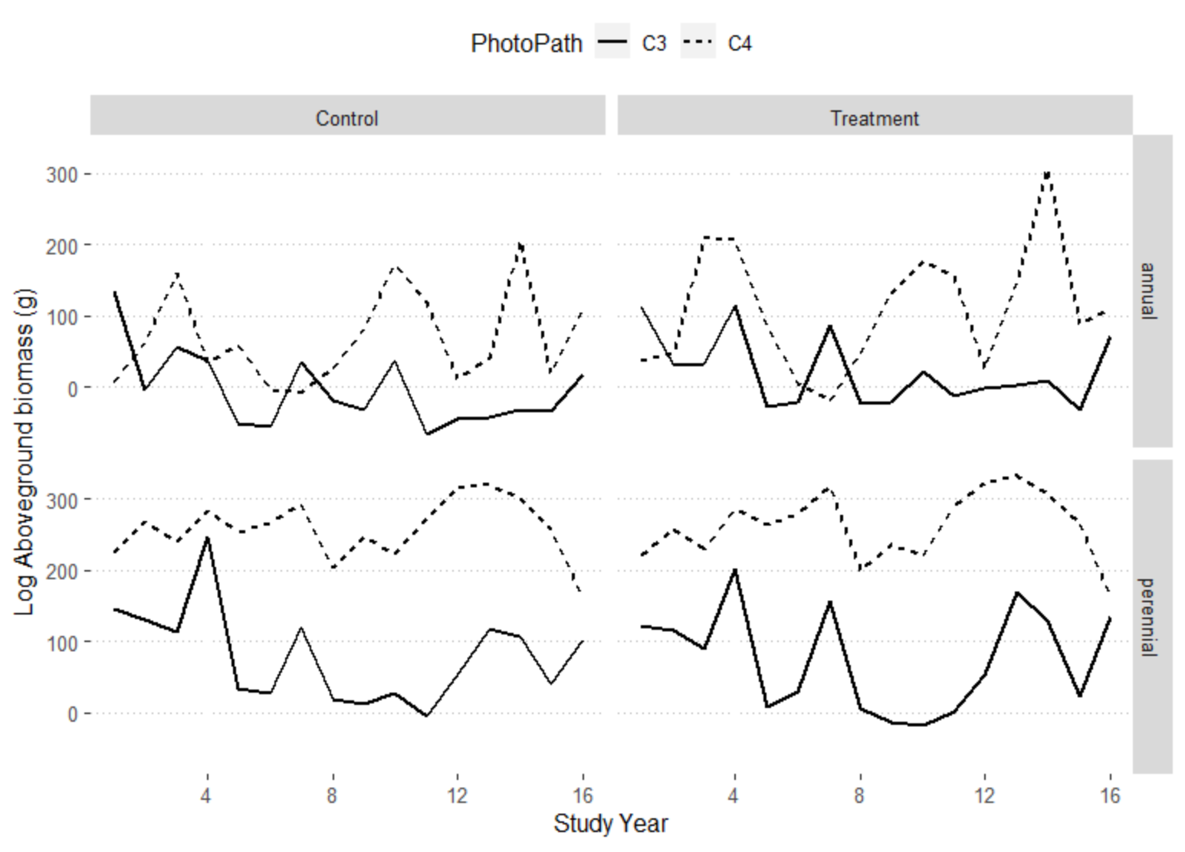

**Fig 2**. Time Series analysis of Log above ground biomass by study year summed by photosynthetic pathway. C3 plants are in solid lines and C4 plants are in dashed lines. Comparison of annual or perennial life history strategy is provided.

**Discussion:**

Unsurprisingly, Nitrogen addition led to an increase in total biomass, following trends found in the literature (LeBauer & Treseder, 2008). This experimental response is common in semiarid grasslands where Nitrogen is a limiting nutrient (Dijkstra *et al.*, 2010). While we were unable to assess precipitation trends in our experiment, (Ladwig *et al.*, 2012), found above-ground biomass production to be linked to seasonal precipitation. This trend, tied with the known water use efficiency of C4 plants, may explain our finding of C4 plants having a significant response to Nitrogen addition, however, our study does not include seasonal precipitation and thus cannot confirm or deny the findings of Ladwig et al. 2012.

While we did not see a significant interaction between treatments and biomass per year when separating by life history strategy, we did find a significant difference between strategies without accounting for time. Further analysis of these mechanisms is required but was out of the scope of our study. However, through the eye test, annual, and perennial plants responded similarly to treatment effects. However, they showed differences in their above-ground biomass fluctuations when separated into the two photosynthetic pathways analyzed in this study. This suggests that the life history strategy alone is insufficient to address the differences between plant group responses to nitrogen addition.

In the future, the inclusion of environmental variables like precipitation or temperature might explain these fluctuations and provide further context for the findings presented in our analysis.

**References:**

Dijkstra FA, Blumenthal D, Morgan JA, Pendall E, Carrillo Y, Follett RF. 2010. Contrasting effects of elevated CO 2 and warming on nitrogen cycling in a semiarid grassland. *New Phytologist* 187: 426–437.

Ladwig LM, Collins SL, Swann AL, Xia Y, Allen MF, Allen EB. 2012. Above- and belowground responses to nitrogen addition in a Chihuahuan Desert grassland. *Oecologia* 169: 177–185.

LeBauer DS, Treseder KK. 2008. NITROGEN LIMITATION OF NET PRIMARY PRODUCTIVITY IN TERRESTRIAL ECOSYSTEMS IS GLOBALLY DISTRIBUTED. *Ecology* 89: 371–379.

**Supplemental Code and Data:**

Included in the attached files.